# 2. PRODUCT DESCRIPTION

**OVERVIEW**

This section of the SRS should describe the general factors that affect the product and its requirements. This section does not state specific requirements. Instead, it provides a background for those requirements, which are defined in detail in Part 3 of the SRS, and makes them easier to understand.

**2.1** **Product Perspective**

The function of Compound System UMP (COSYS) is to ease the procedures of data managing in University Malaysia Pahang (UMP). Since the system is specially designed and produced according to our clients’ preferences, this makes it a system without duplication, independent and self-contained.

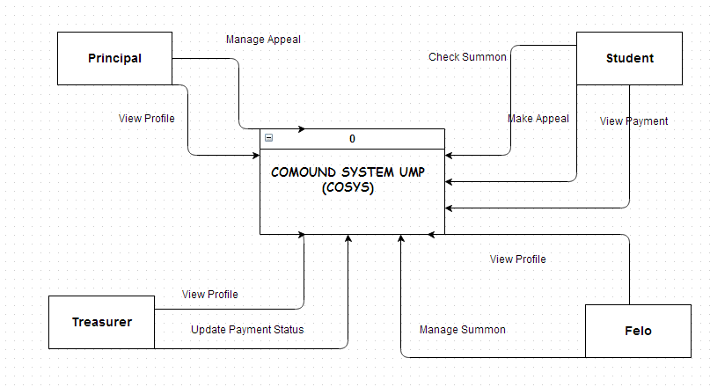

**Figure 2.1** Context Diagram for Compound System UMP (COSYS)

Compound System UMP (COSYS) is a web based application system where the system is capable to run on any internet browser. The function of the COSYS is to easel the inventory in safe way rather than conventional way. COSYS has four kinds of users which are the Student and Admin. This system will have interaction with different function which refers to the students ID to log in into system. The student will have to verify themselves at student page at the system using student ID to get their information such as the View Payment and Check Summon and the information will search through the similar database to get the information.

Besides that, COSYS is divided into three of Admin which are the Felo, Principal and Treasurer. For Admin page it contains Manage Summon, Manage Appeal Summon, Update Payment Status and View Profile. This page is only can be accessed by admin and need to login to access this page. These entire pages are function without any problems as long as it did not cause any unexpected events such as blackout, system corruption and so on.

**2.2 System Interface**

System interfaces is very important part in a system and it is the part that interacts with user. The system interface is a key and determines the application usability; therefore system interface must be user friendly and meet the user requirements. Login page provided to user to enter their Username, Password and Categories to login to enter a system. COSYS has four kinds of users which are the Student and Admin. Student page is provided a menu for student function which student can check their summon, view their payment status and also make an appeal to get discount using an online system.

COSYS has provided a menu page for Admin which are Felo, Principal and Treasurer. Felo page provided menu for felo function which felo can manage summon and view profile. In Principal page at the system, principal can view their profile, and manage appeal. Besides that, Treasurer page is provided a menu for treasurer function which treasurer can view their profile and update payment status.

**2.3 Product Functions**

The Compound System UMP (COSYS) contains the following function:

**2.3.1 Students**

COSYS have four function in student page is a Make Appeal Summon, View Payment, Check Summon and View Status Appeal.

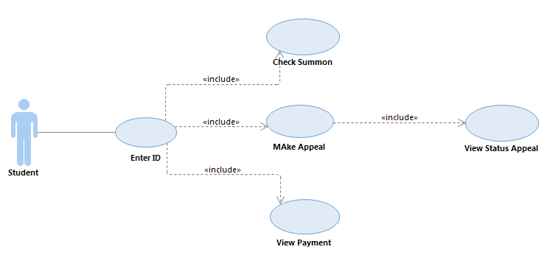

**Figure 2.2** Student Use Case

1. **Make Appeal Summon**: These functions allow student make appeal for summon to student make payment after get the discount.
2. **View Payment**: Once a student navigates past the Check Summon Information, the Compound System UMP will display amount of summon should be pay by students at the Payment Screen.
3. **Check Summon**: These functions allow student is able to view summon information.
4. **View Status Appeal**: These functions allow students to view status appeal after get approval from principal.

**2.3.2 Felo**

COSYS have three function in felo page is a View Profile, and Manage Summon

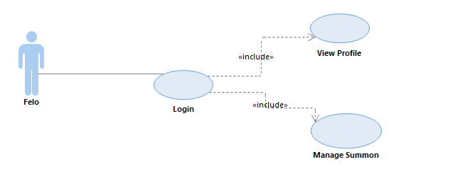

**Figure 2.3** Felo Use Case

1. **View Profile**: These functions allow felo is able to view their information profile.
2. **Manage Summon**: These functions allow felo update summon either felo can edit, delete, or add new record summon.

**2.3.3 Principal**

COSYS have two function in principal page is a View Profile, View Summon, and Manage Appeal.

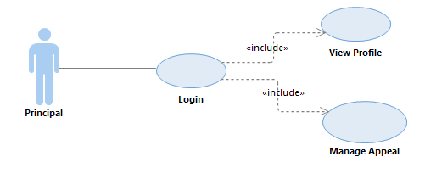

**Figure 2.4** Principal Use Case

1. **View Profile**: These functions allow felo is able to view their information profile.
2. **Manage Appeal**: These functions allow principal to manage appeal for summon either to approve that appeal or not.

**2.3.3 Treasure**

COSYS have two function in treasurer page is a View Profile Information, and Update Payment Status

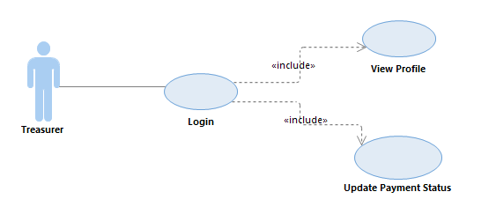

**Figure 2.5** Treasurer Use Case

1. **View Profile**: These functions allow felo is able to view their information profile.
2. **Update Payment Status:** These functions allow treasurer update for payment status after students have been finish paid their payment.

## 2.4 User Characteristics

There are some minimum characteristic that the target users must have in order to access the system. They are:

**Students**: These users should have basic idea on operate the system and already having experience on the system function (Compound System UMP). These users also have to understand the language selected which is English and basic understanding on using a computer.

**Admin**:

1. Felo
2. Principal
3. Treasurer

These users are a limited user for this system, these users are able to manage summon information, and manage appeal summon. These users should have basic idea on operate the system and already having experience on the system function (Compound System UMP). These users also have to understand the language selected which does English and basic understand on using a computer.

## 2.5 Constraints

Points below will explain briefly on the constraints which have to be considered during system development process. The constraints stated here are crucial to be taken care of. There are few constraints confronted in order to meet the basic requirement of the system:

* Interfaces to other applications
* If there is problem occur on another application that interact with this system, this system will not able to solve the problem and perform its function.
* Specific language requirements
* The specific language use to develop this system is C++
* Application that could not read the language of this system would not able to run this system.
* Criticality of the application
* This system will crash or fail to run if same data been alter on both student and admin side.
* Safety and security considerations
* The system only apply verify system
  + - Admin will only have to key in their specific ID for certain page usage.

## 2.6 Assumptions and Dependencies

This subsection of the SRS should list each of the factors that affect the requirements stated in the SRS.

***2.6.1 Assumptions***

* This system designed can be run in any of internet browser such as Mozilla Firefox and Internet Explorer.
* This system is assumed that all the users are familiar with the internet browser and computer basic skills.
* To run this system, it only uses quite low memory of RAM is about 2GBytes for the performance of the application.

***2.6.2 Dependencies***

* The performance of the system application is depends on the memory of ram that the users use when run the system. More ram that users use, more higher the performance of the system application.
* The system also depends on the network also in order to run the system properly.